**Weekly report (first week after Easter)**

**All graph are at the end**

Ran more thorough analyses of shuffling, normalisation, and effects of having many filters per layer as well as many layers. Need to analyse further the effects of max. pooling.

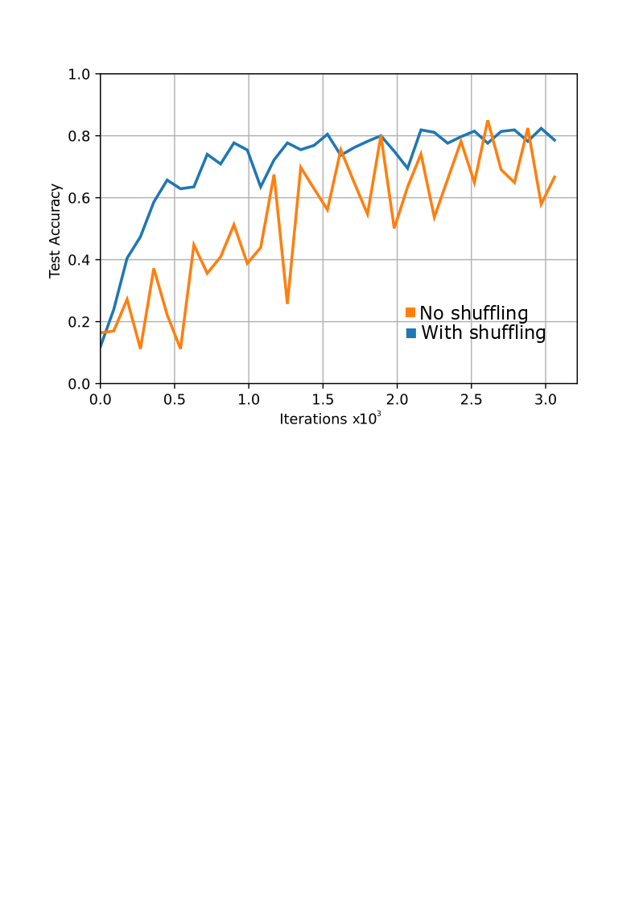

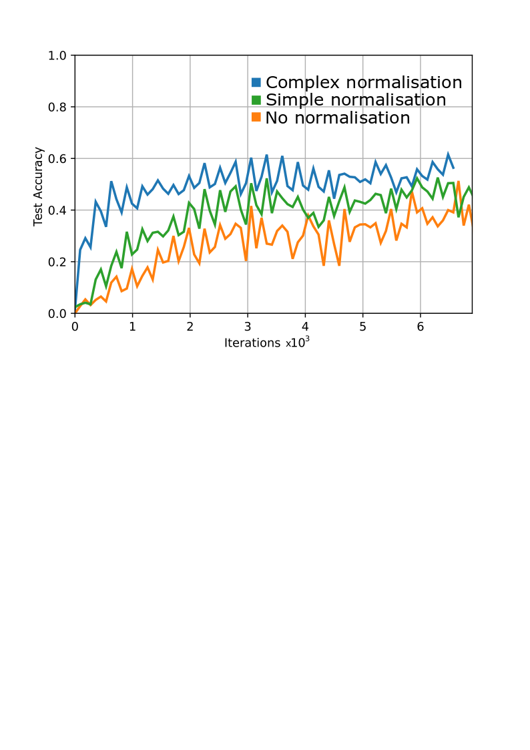

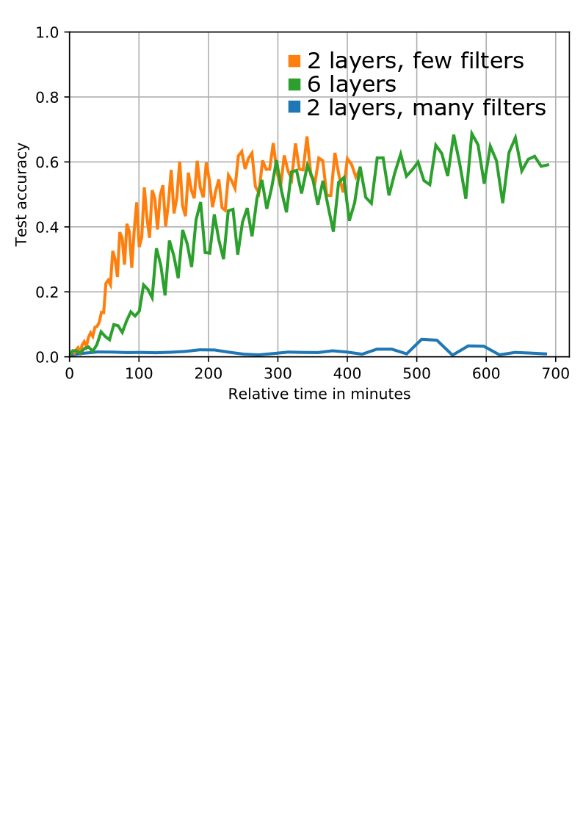

Hongming has provided us with a transcript of the Baotu Spring poem. Used Open-CC online to turn the traditional Chinese characters to simplified Chinese.

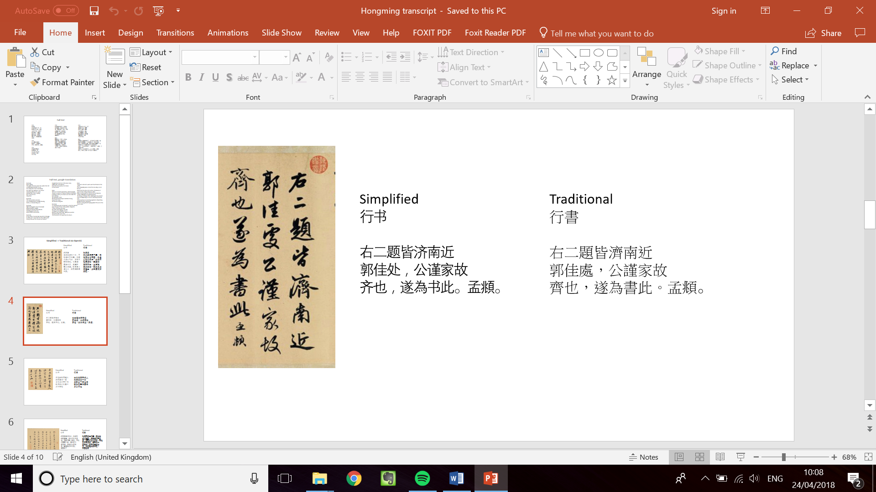

The CASIA database has simplified Chinese only, whereas Baotu Spring consists of traditional Chinese.

Ran feature map analysis again, for some reason it was far more detailed this time. Also wrote code to generate activations for a 4 layer and 6 layer network, as well as to output the weight filters.

*Feature maps from CASIA (1st layer)*

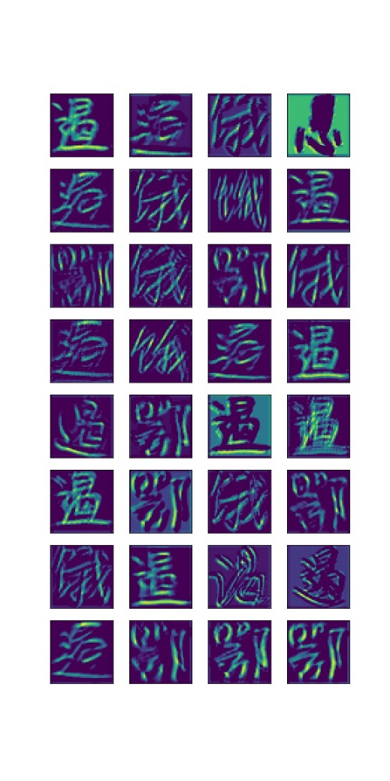

*Feature maps from calligraphy (1st layer)*

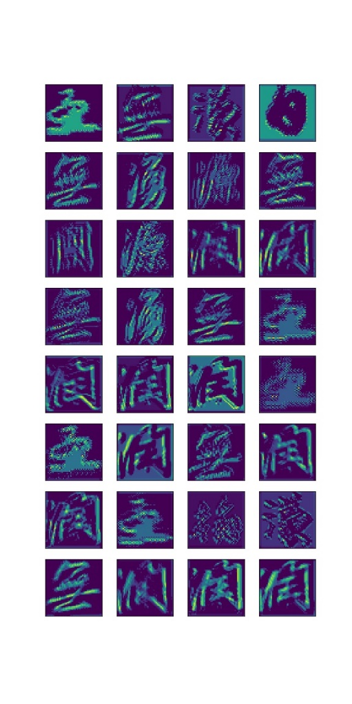

*Feature maps from CASIA (2nd layer)*

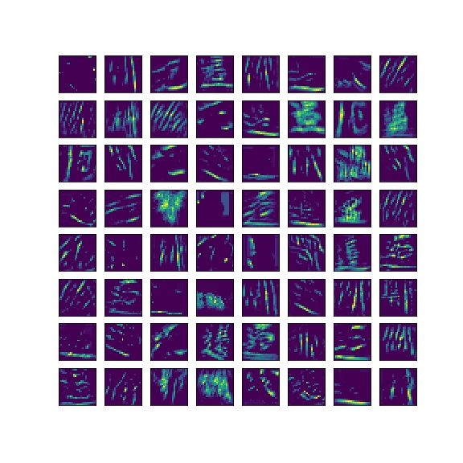

*Weights maps from CASIA (1st layer)*

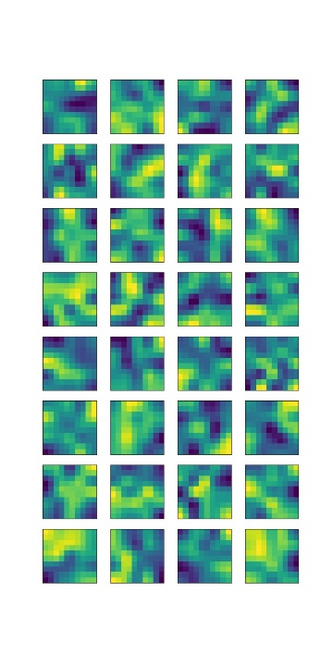

Normalised the segmented calligraphy characters, compiled them into a .tfrecord and tested featuremaps on them.

*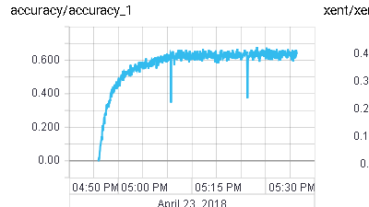***transfer learn on all characters**

Managed to retrain the last layer of the network that was trained on 100 characters to identify all 3866 characters. The result was a convergence in accuracy at around 62%. This is not as high as what is required but it is certainly progress. There were some issues with shuffling the dataset as the buffer size was not large enough. The buffer size needed to be as big as the dataset in order to shuffle effectively. Before it was only 10^3 which meant that the data was shuffled across only part of the dataset.

**Action points for the next week**

* Create a script to deploy the network with the calligraphy
* Reverse engineer a one to one correspondence between the character label number and the actual character.